Session 5.4:

Problem Statement . Output 1. Introduction In this assignment you need to write Java Map reduce programs for the given problem statement 2. Problem Statement Titanic Data Analysis Write a mapreduce program to find out number of males and females died in the titanic tragedy. Download the Titanic data set from the below link Titanic_Dataset DATA SET DESCRIPTION

Column 1 : PassengerId

Column 2 : Survived (survived=0 & died=1)

Column 3 : Pclass

Column 4 : Name

Column 5 : Sex

Column 6 : Age

Column 7 : SibSp

Column 8 : Parch

Column 9 : Ticket

Column 10 : Fare Column

11 : Cabin

Column 12 : Embarked

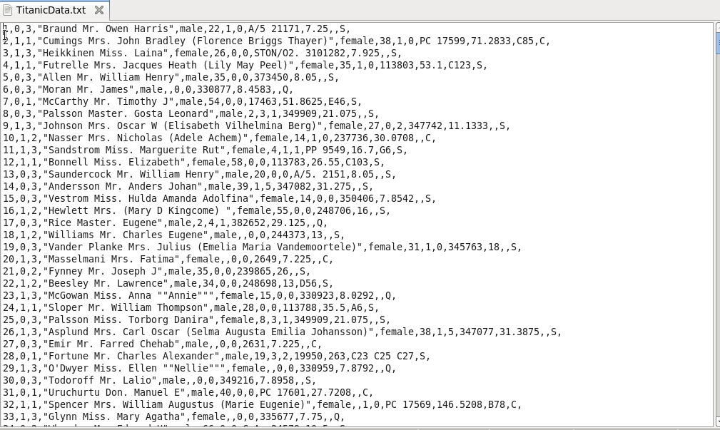

**DRIVER**

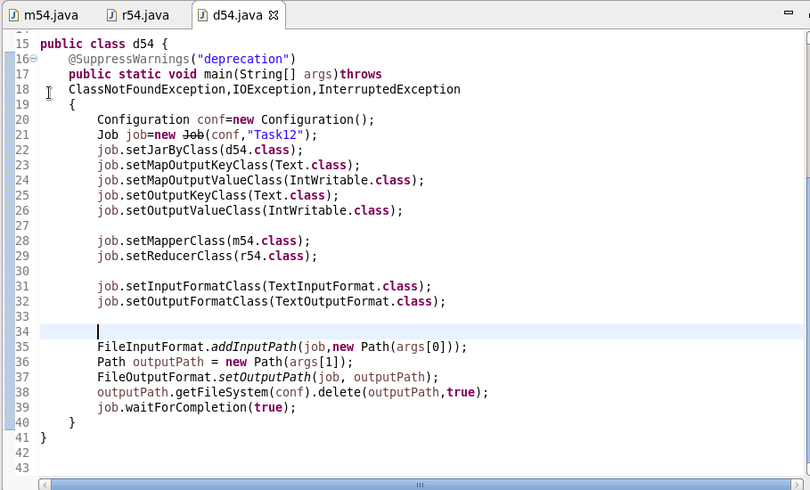



**Mapper**

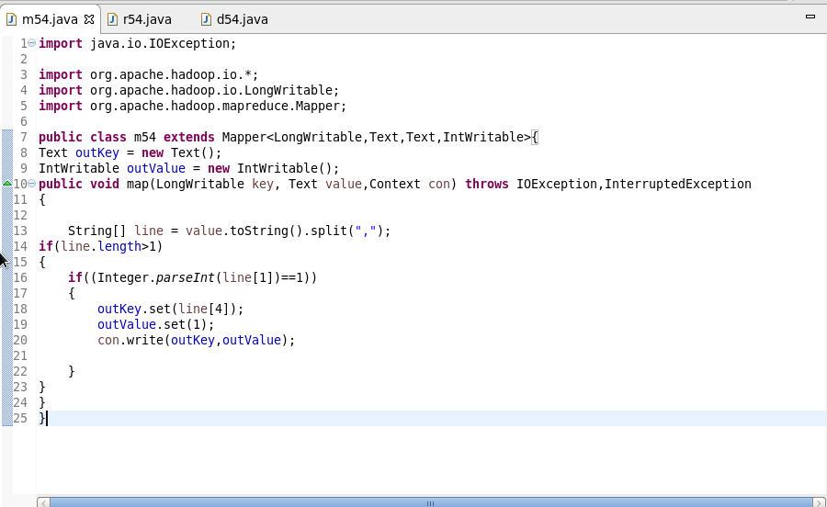

**Reducer**

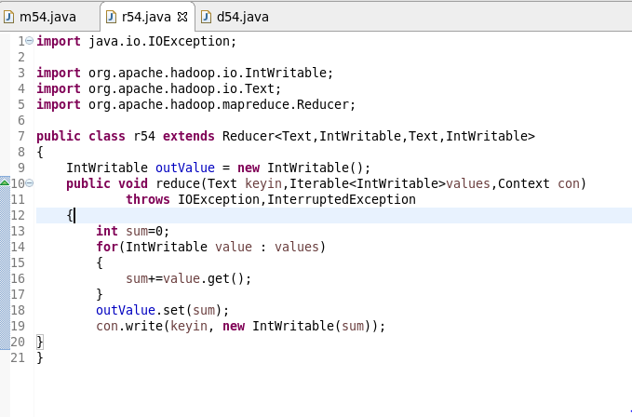

**Output**

